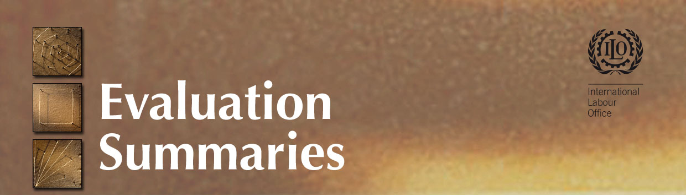

Prevention of HIV/AIDS in the World of Work: A Tripartite Response (Phase II) in India

Quick Facts
Country: India
Final Evaluation: October 2008
Mode of Evaluation: Independent
Technical Area: Labour and HIV/AIDS
Evaluation Management: HIV/AIDS
Evaluation Team: Mei Zegers
Project Start: 2003
Project End: 2009
Project Code: IND/05/01/UNA
Donor: United States Dept of Labor (US$2,000,000 for Phase I and II), plus additional $ 330,000 under the US President’s Emergency Plan for AIDS Relief (PEPFAR)
Keywords: HIV/AIDS, Social Dialogue

Background & Context
Summary of the project purpose, logic and structure
The overall objective for the project was to contribute to the prevention of HIV/AIDS in the world of work, the enhancement of workplace protection and the reduction of adverse consequences on social, labour and economic development. Phase II of the project has sought to consolidate and build on effective strategies developed under Phase I.

The long-term objective is to be accomplished by pursuing three Immediate Objectives:
- Increased capacity of ILO’s tripartite constituents to adopt and implement effective workplace policies and programs to prevent the spread of HIV, and the discrimination and stigmatization of PLHA.
- Enhanced tripartite action against HIV/AIDS in the five selected states and the city of Mumbai covering workers in the formal and informal sectors.
- Develop a plan of action for Phase 3 aiming at a sustainable mechanism for the world of work response to HIV/AIDS.

The ILO’s strategy is to work with business, labour, and government leaders to develop their awareness of the existing and growing danger of HIV/AIDS and to act to address it in the workplace. This was to be accomplished through an information and awareness raising campaign of presentations, workshops, and technical assistance to business, labour, governmental and NGO groups. These are to be complemented by an effort to increase understanding of the existing situation, and the development of support materials designed to increase capacity among stakeholders to support workplace-based HIV/AIDS policies and programs, and to induce change in behaviour.

Phase II (A): Implemented from January 2003 – December 2005 in the states of Jharkhand, Madhya Pradesh and West Bengal and in the city of Mumbai; apart from providing technical support to Ministry of Labor & Employment (MOL&E), National AIDS Control Organization (NACO), Employers’ and Workers’ Organization, and People Living with HIV/AIDS (PLHIV).
Phase II (B): Currently being implemented from January 2006 till May 2008. This phase has included Delhi as an additional state, apart from continuation of ongoing work in the states of Jharkhand, Madhya Pradesh, West Bengal and city of Mumbai. The project also provides technical support to the MOL&E, NACO/SACS, Employers’ and Workers’ Organization, and PLHIV. Another feature of this expansion is the projects focus on big corporate groups in India in order to upscale enterprise based interventions. The project is also providing technical support in the state of Goa, where the implementation is being done with funds from UNAIDS (PAF- Program Acceleration Fund).

Present situation of project
Originally intended to be completed in 2005, the project was extended to 2008 in Phase II-B. The Project started receiving additional top up funds, under PEPFAR since FY 2006-2007, which enabled it to be extended till September 2009. PEPFAR funds are routed through USDOL, and are likely to continue during the National AIDS Control Plan -III.

Purpose, scope and clients of the evaluation
- Determine if the project has achieved its stated objectives since the internal assessment reports and explain why/why not;
- Assess the impact of the project in terms of the sustainability of its achievements;
- Determine the level of satisfaction from project activities by its tripartite constituents;
- Assess the HIV/AIDS knowledge, attitude, behaviour and practices of workers of partner enterprises in the project states of Phase II(B) as evidenced by the Data Tracking Table/final survey results.
- Assess the impact of the project in terms of its contribution towards National Policy/ Programs on HIV/AIDS in the world of work;
- Assess the impact of the Project in building capacity of constituents and PLHIV in undertaking advocacy and interventions at workplaces;
- Provide recommendations for the project in view of its continuation under PEPFAR.
- Provide recommendations on how to improve project performance, and where necessary, identify the possible need to refine strategy for successful integration of WPI in the third phase of the National AIDS Control Programme (NACP-III 2007-2012);
- Make recommendations to USDOL and PEPFAR on the relevance/nature of further support to ILO in India.

Methodology of evaluation
Most of the data was collected during the evaluator’s fieldwork in India in May 2008 for a larger cross-country study about the Strategic HIV/AIDS Responses in Enterprises (SHARE) program. Information was updated through a phone conference with the project team and analysis of updated materials in September 2008. A combination of methods was used to ensure a thorough and well-rounded evaluation could be carried out. This included document review, background interviews, and field visits where the evaluator conducted individual interviews, small group discussions, and observation. The types of stakeholders interviewed included project staff, government and NGO personnel at the national and provincial/state levels, workers’ organizations and individual enterprises.

Main Findings & Conclusions

The project has achieved good impact at national level, and also among corporate groups and institutions associated with the project. Several institutions, such as the CBWE, continue to identify new opportunities to integrate HIV in workplace programs and will need technical support to implement them. The country also functions through a federal system and state level policies and strategies need to be developed and implemented. Impetus for change and real impact can only be attained by strong joint efforts of all major stakeholders at all levels, i.e., through all of the tripartite constituents and their civil society partners. Corporate groups can also play a major role by setting an example and promoting HIV programs in other corporations. At the same time, HIV issues are being mainstreamed into the different government departments at national and state level. The result is a complex mix that will require time to ensure that policies and strategies promoting HIV in the world of work are developed and implemented.

Recommendations & Lessons Learned
Main recommendations and follow-up
- The project needs more time to consolidate efforts already underway, ensure impact monitoring, and provide technical support for up-scaling. A third phase with funding through USDOL is recommended.
- A system for improved tracking of the implementation of policies adopted by the tripartite constituents and their NGO partners needs to be developed.
- Advocacy is needed for increased budget allocations to national government level programs that address HIV in the workplace to improve long term sustainability.
- Gender issues, particularly on women’s rights, need to be addressed in more detail in capacity strengthening exercises and all materials.
- Indicators should be limited in number, be highly indicative of key impact and include targets that are based on the level of change that can be expected after analyzing baseline results.
- Target sectors that need more attention in the future include public sector, migrant, construction and (other) informal economy workers.
- Creating more networks with other ILO and agencies’ projects specializing in livelihoods and skills development would be useful.

Important Lessons Learned
- The choice of an effective focal person within enterprises is essential.
- Have corporate groups invest financially in their HIV program since it added to their sense of ownership and interest in sustaining their program.
- The project found that it is more effective to gradually build up the programs and not to try to “push everything on them at once.”
- It is more effective to work first on basic advocacy, develop and deliver training and finally introduce concrete proposals for a workplace policy.
- The use of Knowledge, Attitudes and Practices studies at the beginning of a project is very useful as an advocacy tool.
- Economic ramifications are a key factor in raising awareness for companies to implement a program on HIV.
- It is vital to work very closely with the corporate groups for the program to be successful.
- The development of the policy can be a long and arduous process. The only way to ensure that the policies are supported by a broad platform is to develop them through a consensus building process.
- Pushing companies strongly to pass policies from the beginning is not effective as they might adopt policy but not enforce it. Companies need to be fully in favour of the policy before adopting it formally.
- Ensure from the first meetings that the roles and resources needed from implementers of the programs were clear.
- Throughout all activities it is more effective to mix HIV Workplace activities with other approaches on health, security and other concerns affecting the workplace.

