Peer review and Knowledge Sharing Workshop 2018

Asia Regional Thematic Evaluation on Social Protection (2012-2017)

To ensure the soundness of recommendations, their originality and the correctness of findings presented in the draft Asia regional thematic evaluation (RTE) report on social protection for the period of 2012-2017, Regional Office For Asia and the Pacific (ROAP) conducted a knowledge sharing workshop on Monday, 7 May 2018 and a Skype call with Social Protection Department (SOCPRO) officials in HQs on 8 May 2018.

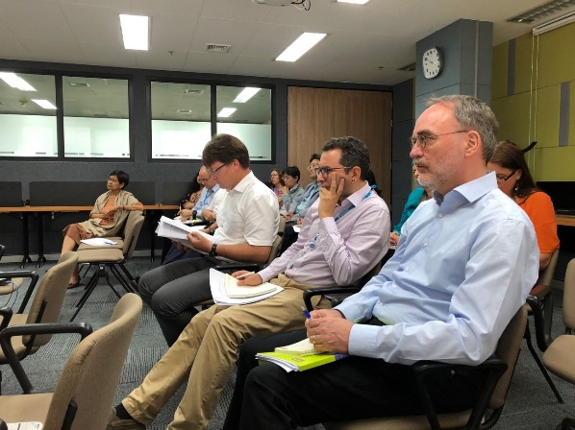

Deputy Regional Director of ROAP, Director of DWT-Bangkok, Social Protection Specialists, UNESCAP colleagues participate in the knowledge sharing work shop on thematic evaluation on social protection.

The knowledge sharing workshop provided opportunities for colleagues, other key collaborators and development partners who have worked in social protection areas to discuss the findings and recommendations in the RTE report. Conducting the knowledge sharing workshop was also part of our approaches to enhance wider use of evidence-based evaluations for strategic planning, programme planning and decision making across the ILO’s Regional Office for Asia and the Pacific (ROAP). The independent evaluator, Mr. Mel Cousins, presented methodology, findings and recommendations which informed set strategic directions on social protection for the ROAP in the future taking into account the challenges and new developments in the region including the SDGs. The main methodology of this RTE focused on data analysis, interviews with key stakeholders in the region (e.g. ASEAN and other UN agencies), and synthesis of findings from seven case studies on social protection for Viet Nam, Lao PDR, Cambodia, Thailand, Mongolia, India and Nepal that were part of the 2017 ILO’s High Level Evaluation on social protection.

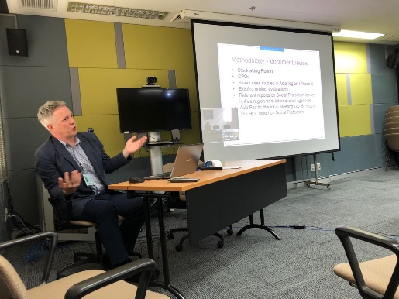

Mr. Mel Cousins presents the findings and recommendations from the thematic evaluation report on social protection.

A total of 23 participants from ROAP, DWT-Bangkok, DWT-New Delhi, UNESCAP and independent consultants actively participated in the workshop, provided their comments and feedback and sought clarification on the presentation of the RTE findings and recommendations.

After the knowledge sharing workshop, the social protection specialists and ROAP management have shown their enthusiasm in taking ownership of the evaluation recommendations as demonstrated by their initiative in developing regional social protection plan and strategy for the next five years.